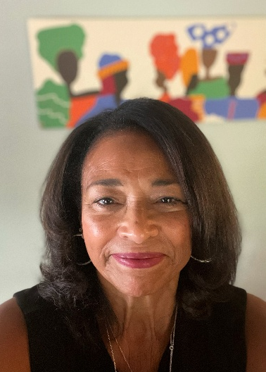
KELLEY NEAL GRAY
Sponsor, George M. Neal (DDG 131)

Kelley Neal Gray was born on September 18, 1957, to George Milton Neal and Barbara Trimble Neal, as the second of their two children. She grew up in Springfield, Ohio, alongside her brother, Van Neal.

Kelley is a proud graduate of Springfield South High School, following in the footsteps of both her parents and her brother. She began working in retail during high school and continued throughout college, developing an early passion for merchandising and retail leadership.

Kelley earned an Associate of Arts degree in Fashion Merchandising from the Art Institute of Atlanta and began her career in management at Rich’s Department Stores in Atlanta, Georgia. Realizing that achieving her goal of becoming a fashion buyer would require a four-year degree, Kelley returned to Springfield. While working full-time at a local factory, she continued her education and earned a Bachelor of Science degree in Marketing from Central State University.

Kelley married the love of her life, Eric Gray, and the couple moved to New Jersey, where she worked as a Fashion Buyer for Petrie Stores. After Eric received a job opportunity that brought them back to Ohio, Eric and Kelley made their home in Columbus.

Kelley joined L Brands, one of Ohio’s premier retailers, where she built an exceptional 30-year career. She spent 15 years with Victoria’s Secret and concluded her distinguished career as Assistant Vice President of Merchandise Planning and Allocation at Bath & Body Works.

Kelley is an active member of the First Church of God in Columbus, Ohio. She is also a member of The Links, Incorporated, Twin Rivers (OH) Chapter; The Circle-Lets, Inc., Columbus Chapter; and a past President of Jack and Jill of America, Columbus Chapter. She also previously served on the Board of Directors for the Lincoln Theatre.

Kelley and Eric are the proud parents of two adult children, Neal and Erica.

In retirement, Kelley feels deeply blessed to spend time with Eric enjoying golf, gardening, travel, and wintering in Sarasota, Florida.
Kelley is especially honored to represent her family as the sponsor of the USS George M. Neal (DDG 131), a United States Navy destroyer named in honor of her father, George Milton Neal.

